***Part 1:***

create database homework3;

use homework3;

create table customer(

cus_code int,

cus_lname varchar(20),

cus_fname varchar(20),

cus_initial char,

cus_areacode int,

cus_phone int,

primary key(cus_code));

create table invoice(

inv_number int,

cus_code int,

inv_date datetime,

primary key(inv_number),

foreign key(cus_code) references customer(cus_code));

create table vendor(

vend_code int,

vend_name varchar(30),

vend_contact varchar(30),

vend_areacode int,

vend_phone int,

primary key(vend_code));

create table product(

prod_code int,

prod_desc varchar(50),

prod_price int,

prod_quant int,

vend_code int,

primary key(prod_code),

foreign key(vend_code) references vendor(vend_code));

create table line(

inv_number int,

prod_code int,

line_units int,

primary key(inv_number, prod_code),

foreign key(inv_number) references invoice(inv_number),

foreign key(prod_code) references product(prod_code));

***Part 2:***

/* cus_code, cus_lname, cus_fname, cus_initial, cus_areacode, cus_phone */

insert into customer values (10010, "Ramas", "Alfred", 'A', 615, 8442573);

insert into customer values (10011, "Dunne", "Leona", 'K', 713, 8941238);

insert into customer values (10012, "Smith", "Kathy", 'W', 615, 8942285);

insert into customer values (10013, "Olowski", "Paul", 'F', 615, 2221672);

insert into customer values (10014, "Orlando", "Myron", NULL, 615, 2971228);

/* inv_number, cus_code, inv_date */

insert into invoice values (1001, 10011, '2008-08-03');

insert into invoice values (1002, 10014, '2008-08-04');

insert into invoice values (1003, 10012, '2008-03-20');

insert into invoice values (1004, 10011, '2008-09-23');

/* vend_code, vend_name, vend_contact, vend_areacode, vend_phone */

insert into vendor values (232, "Bryson", "Smith", 615, 2233234);

insert into vendor values (235, "SuperLoo", "Anderson", 615, 2158995);

/* prod_code, prod_desc, prod_price, prod_quant, vend_code */

insert into product values (12321, "hammer", 189 ,20, 232);

insert into product values (65781, "chain", 12, 45, 235);

insert into product values (34256, "tape", 35, 60, 235);

insert into product values (12333, "hanger", 200 ,10, 232);

/* inv_number, prod_code, line_units */

insert into line values (1001, 12321, 1);

insert into line values (1001, 65781, 3);

insert into line values (1002, 34256, 6);

insert into line values (1003, 12321, 5);

insert into line values (1002, 12333, 6);

/* 1 List the First name, middle initial, last name, and area code for all customers.

*/

SELECT customer.cus_fname, customer.cus_lname, customer.cus_areacode

FROM customer

ORDER BY customer.cus_areacode;

/* 2 List the invoice number and invoice date for all invoices of customer number 10011.

*/

SELECT invoice.inv_number, invoice.inv_date

FROM invoice

WHERE invoice.cus_code = 10011

ORDER BY invoice.inv_number;

/* 3 List the product number and product quantity for products in invoice number 1001

*/

SELECT product.prod_code, product.prod_quant

FROM product

JOIN line ON line.prod_code = product.prod_code

JOIN invoice ON line.inv_number = invoice.inv_number

WHERE invoice.inv_number = 1001

ORDER BY prod_code;

/* 4 List all product description and product price supplied by vendor whose vendor

contact name is Smith

*/

SELECT product.prod_desc, product.prod_price

FROM product

JOIN vendor ON product.vend_code = vendor.vend_code

WHERE vendor.vend_contact = "Smith"

ORDER BY prod_price;

/* 5 Produce a list of product description, vendor name, and vendor phone for all

products with price less than 50.

*/

SELECT product.prod_desc, vendor.vend_name, vendor.vend_phone

FROM product

JOIN vendor ON vendor.vend_code = product.vend_code

WHERE product.prod_price < 50

ORDER BY vend_name;

/* 6 For each product bought by a customer, list product description and

customer’s first name and last name.

*/

SELECT prod_desc, cus_fname, cus_lname

FROM customer

JOIN invoice ON customer.cus_code = invoice.cus_code

JOIN line ON line.inv_number = invoice.inv_number

JOIN product ON product.prod_code = line.prod_code

ORDER BY cus_lname;

***Part 3:***

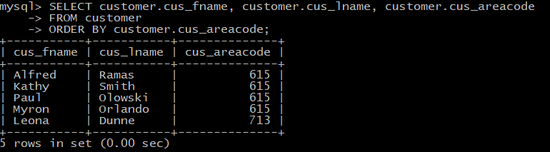

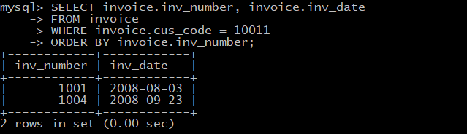

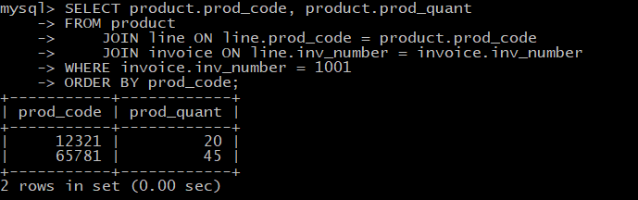

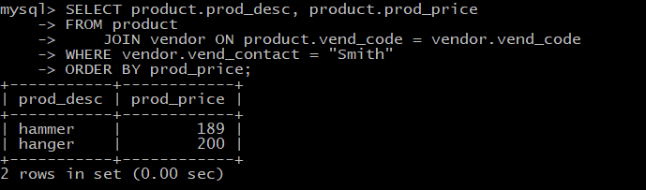

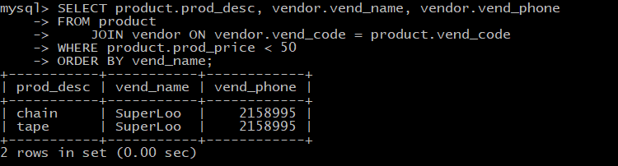

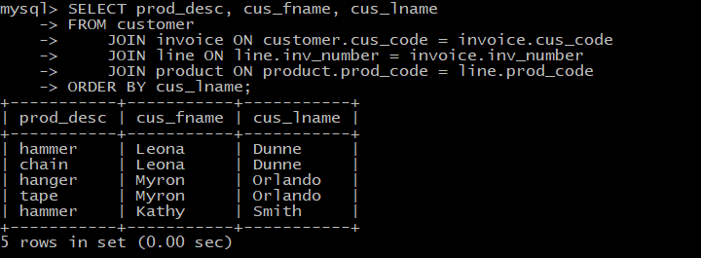

***Part 4:***

1. The statement did not execute. The cus_code entry for this is a duplicate meaning someone in the database already has this cus_code(PK). Primary keys must be unique; therefore, this cannot work.
2. The statement did not execute. The fact that the table INVOICE uses the foreign key cus_code which is the primary key for the table CUSTOMER, means that for us to put the value “10017” into invoice would mean that it must first exist in the table CUSTOMER as a cus_code. You cannot update or add to a child row information that does not exist in its parent. We could fix this error by adding an entry for a customer in table CUSTOMER using the cus_code(PK) 10017.
3. The statement did not execute. Again, this query tries to update and add to a child row. The foreign key vend_code in table PRODUCT is also the primary key in table VENDOR. Therefore, the value “231” must exist in table VENDOR as a vend_code(PK) before it can be added to table PRODUCT as vend_code(FK). We could fix this issue by adding a new vendor entry in table VENDOR with vend_code(PK) as 231.
4. This query executed with no problems. It added a new entry into vendor with the vend_code = 231 which should now allow us to assign products using the newly added vendor entry.
5. This query executed with no problems. We have addressed and fixed the issue faced in problem #3. Since we added a new entry to table VENDOR using the vend_code 231, we can now assign products in table PRODUCT using vend_code 231 since it now exists in the parent.